Table of Contents

Strategic Alliance 1

Benefits 1

Historical Development 2

Examples 3

IBM and Apple 3

References 3

# Strategic Alliance

A strategic alliance is an approach to an agreement where two organizations work together on a project that benefits both parties while maintaining independence (KENTON, n.d.).

In a strategic alliance, there are three key terms.

**Strategic**: this refers to the identification of long-term or overall goals and objectives, as well as the means to achieve them.

**Alliance**: An alliance is a grouping of countries or organizations formed for mutual benefit.

**Innovation**: a new method, idea, product, etc.

In this era of globalization, we tend to be surrounded by various strategic and innovative ideas all of these lead to easiness and Wellness of human life. Basically, these alliances that are based on common interests tend to serve the majority of people so that the benefit can be shared along with the ideas and resources that are to be utilized during the process of delivering a common goal/product.

Strategic alliance terms or any such agreement of terms could benefit and enhance companies’ ways of developing a more effective process to reach shared profit and larger audience.

Strategic alliances allow two or more organizations, individuals, or other entities to work toward common or correlating goals. One such strategic Alliance example uber with Spotify uber makes users use their playlist and stream them easily while riding so this makes Uber ride more user-friendly and makes them tempting to buy Spotify premium. At the same time, other riding Giants don't have such specific personalized experiences which makeover a more favorable compared to others.

This also makes room for Uber users without Spotify, as well as Users without uber using Spotify to groove into music without using Uber services. This in turn expands the brand into business opportunities because of the collaboration in place. (Kalia, n.d.)

## Benefits

Following are the benefits of a strategic alliance,

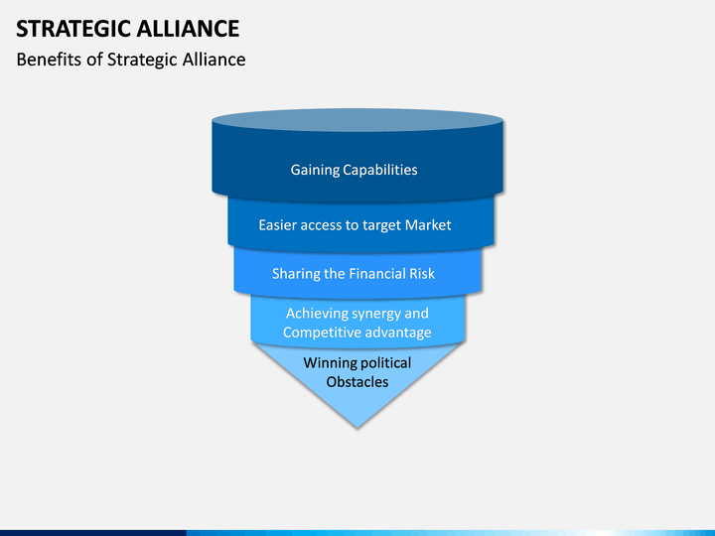

Figure 1Benefits of Strategic Alliance

## Historical Development

The fundamental goal of strategic alliances in the 1970s was to improve product performance and reaction. The partners desired the best quality raw material at the lowest feasible price, as well as the best technology that could be combined with innovations to increase market penetration, but the focus was primarily on the product itself. (Kinderis)

The goal around the 1980s was to create economies of size and scope. It featured businesses attempting to establish their places and reputations in their respective industries. The number of strategic relationships has skyrocketed. Some of these collaborations result in huge product successes:

* Canon photocopiers sold under the Kodak brand name.
* the Toshiba-Motorola cooperation, which combined resources and technology to achieve remarkable success with microprocessors.

Geographic barriers between markets began to crumble in the 1990s, and global markets became more accessible. Higher company requirements necessitated ongoing innovation for competitive advantage, ensuring that new products/offers/devices are available in the marketplace to set them apart from their competitors. The emphasis shifted to the development of skills and abilities.

## Examples

### IBM and Apple

Companies like IBM and Apple involved in strategic alliances with many others first came together in the year 1991, in 2014 they came together for a product for sharing their respective resources and ideas called business applications the title of the project was ‘mobile-first. (Gomes-Casseres, n.d.)

As both the companies were equipped with the knowledge and new technologies, they were capable enough to reach markets, on the road to success they held each other’s hands in the most strategic way together, keeping terms and conditions to work for the product separately and the idea of strategic alliance came to serve the product as means of business propagation and wider audience reach. This partnership helped in creating a new customer for apple's new product iPad reach a wider audience and also at the same time the low-lying business revenues of IBM were replenished. (Apple and IBM Forge Global Partnership to Transform Enterprise Mobility, n.d.)

|  |  |  |
| --- | --- | --- |
| Strategic Alliance | Motive | Form |
| IBM & Apple | To combine knowledge, skills, and technologies to develop a new product: Business application | Joint Product Development |
| Position in Value chain | Position Business Life Cycle |
| Product and manufacturing alliance, in the sector of production. | Product innovation in the early growth phase |

# References

*Apple and IBM Forge Global Partnership to Transform Enterprise Mobility*. (n.d.). Retrieved from Apple.com: https://www.apple.com/in/newsroom/2014/07/15Apple-and-IBM-Forge-Global-Partnership-to-Transform-Enterprise-Mobility/#:~:text=CUPERTINO%2C%20California%20and%20ARMONK%2C%20New,capabilities%20to%20iPhone%20and%20iPad.

Gomes-Casseres, B. (n.d.). *From Rivals to Partners — IBM and Apple*. Retrieved from Alliancestrategy: https://alliancestrategy.com/from-rivals-to-partners/

Kalia, V. (n.d.). *Strategic alliance defination*. Retrieved from Workspan: https://www.workspan.com/blog/strategic-alliance-definition/

KENTON, W. (n.d.). *Strategic Alliance*. Retrieved from Investopedia: https://www.investopedia.com/terms/s/strategicalliance.asp#:~:text=A%20strategic%20alliance%20is%20an,create%20a%20separate%20business%20entity.

Kinderis, R. (n.d.). STRATEGIC ALLIANCES – THEIR DEFINITION AND FORMATION. *Latgale National Economy Research*.